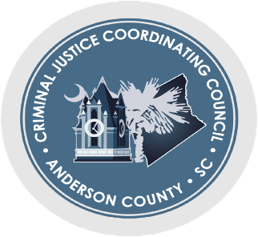

CJCC Meeting Minutes/ August 8th, 2022- 4pm
Joint Information Center
200 Bleckley Street, Anderson, SC 29625

Attendees: 17 Total (Who signed the sheet)

Auburn Walker-Callahan
Matthew Muth
Maria Torres-Green
Paula Payton
Leigh Huckins
Karen Bowen
Don Brookshire
Greg Shore
Jon Caime
Vicki Redding
Captain David Baker
Sara B. Morrell
Caden Smart
Upstate Warriors Solution Representative
Chairman George Ducworth
Vice-Chairman Bobby Rettew
Carrie Skeen

Minutes from June 20, 2022 were approved

Community Connections Committee Report
- Maria Torres-Green will now be the Chair for Community Connections

Case Management Review/Detention Center Population Committee Report
(Captain David Baker Providing Update)
- AC Jail population up to 430 inmates
- Recently, 3 inmates pled to murder (2 involuntary and 1 voluntary)

Anderson County Detention Facilities Corporation
- Civilian board members
- Formation meeting was on June 15, 2022
- Requests for qualification to build the jail:
  - Whoever comes to design the jail, they have to have knowledge of jail building and knowledgeable of South Carolina codes.
- Three phases for building the new jail:
  - 1. Design and demolition
  - 2. Physical construction
  - 3. Demolition of current jail and repurposing of “new” current jail (women’s pod) by putting juveniles in them
- 750 beds
- Room to expand more beds with future growth of Anderson County
- Interview process and architectural proposal will be done by mid-August.
  - The board will pick who will build
- Project to not exceed 55 million

Next Meeting: September 12, 2022 - 4pm
- Joint Information Center, 200 Bleckley Street, Anderson, SC 29625

