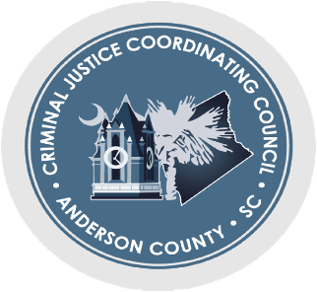

CJCC Meeting Minutes/ October 9th, 2023- 4pm
Joint Information Center
200 Bleckley Street, Anderson, SC 29625

Attendees: 13 (Who signed the sheet)

Carrie Miller
George Ducworth
Chief Jim Stewart
Carter Cheek
Captain David Baker
Dave Phillips
Rev. James Clark
Paula Peyton
Matthew Muth
Marlene McClain
Vicki Redding
Karen Bowen
Lt. Nathan Mitchell

Minutes from September were approved

Detention Center Population Committee Report and New Jail Update
(Captain David Baker Providing Update)
- 415 people in ACDC today
- Moving ACDC Review meeting to 3:30 rather than 3:00
New Jail
- County council meeting last Friday
- Almost at the end of the design phase
- Hope to be done with design by the end of the year (2023)
- After approval, bid to contractor
- Maybe see construction beginning in Spring 2024

Mental Health / Veteran’s Court
(Marlene McClain Providing Update)
- Awaiting the Chief Justice’s approval
- Brochures are at the printer now
  - 1,500 printed to start
- Supreme Court meeting on October 30th with all Mental Health and Veteran’s Court systems

South Carolina Criminal Justice Systems Conference
(George Ducworth Providing Update)
- Taking place in Charleston
  - 10/20, 8:30a-3p
- Invited the group to go if available

Community Connections Report
(Dave Phillips Providing Update)
- Still looking for space for Hope Village 2

Next meeting: November 13th, 2023 at 4pm

